Task 5: Transaction-Based Payment Simulation
Aim: To simulate a secure payment transaction between a user and a merchant using database operations. To ensure data consistency by committing successful transactions and rolling back failed ones.
Algorithm:
- Start
- Get userId, merchantId, and amount from input
- Connect to database
- Start database transaction (BEGIN)
- Fetch user balance from database
- Check if user exists
- If user does not exist → stop and show error
- Check if user balance ≥ amount
- If insufficient balance → stop and show error
- Deduct amount from user account
- Add amount to merchant account
- Insert transaction record with status = "SUCCESS"
- Commit the transaction (COMMIT)
- Display "Payment Successful"

PROGRAM:
Index.html
<!DOCTYPE html>
<html>
<head>
<title>Payment Simulation</title>
</head>
<body>
<h2>Transaction System</h2>
<input id="userId" placeholder="User ID">
<input id="merchantId" placeholder="Merchant ID">
<input id="amount" placeholder="Amount">

<button onclick="pay()">Pay</button>
<p id="result"></p>
<script>
async function pay() {
const response = await fetch("http://localhost:3000/transfer", {
method: "POST",
headers: {
"Content-Type": "application/json" },
body: JSON.stringify({
userId: document.getElementById("userId").value,
merchantId: document.getElementById("merchantId").value,
amount: document.getElementById("amount").value
})
});
const data = await response.json();
document.getElementById("result").innerText = data.message;
}
</script>
</body>
</html>
Db.js
const mysql = require("mysql2");
const pool = mysql.createPool({
host: "localhost",
user: "root",
password: "MySQL@1234",
database: "payment_db"
}
);
module.exports = pool.promise();
Package.json
{
"name": "payment-simulation",
"version": "1.0.0",
"description": "",
"main": "index.js",
"scripts": {
"test": "echo \"Error: no test specified\" && exit 1"
},
"keywords": [],
"author": "",
"license": "ISC",
"type": "commonjs",
"dependencies": {
"body-parser": "^2.2.2",
"cors": "^2.8.6",
"express": "^5.2.1",
"mysql2": "^3.22.0"
}
}
Server.js
const express = require("express");
const db = require("./db");
const cors = require("cors");
const app = express();
app.use(express.json());
app.use(cors());
app.post("/transfer", async (req, res) => {
const { userId, merchantId, amount } = req.body;
const connection = await db.getConnection();

try {
await connection.beginTransaction();
// 1. Check user balance
const [rows] = await connection.query(
"SELECT balance FROM users WHERE id = ?",
[userId]
);
if (!rows.length || rows[0].balance < amount) {
throw new Error("Insufficient balance");
}
// 2. Deduct from user
await connection.query(
"UPDATE users SET balance = balance - ? WHERE id = ?",
[amount, userId]
);
// 3. Add to merchant
await connection.query(
"UPDATE merchants SET balance = balance + ? WHERE id = ?",
[amount, merchantId]
);
// 4. Commit transaction
await connection.commit();
res.send({ message: "Payment Successful" });
} catch (err) {
await connection.rollback();
res.status(400).send({ message: err.message });
} finally {
connection.release();
}
});

app.get("/", (req, res) => {
res.send("Payment Simulation API is running successfully");
});
// ✅ IMPORTANT: server should start ONLY ONCE here
app.listen(3000, () => {
console.log("Server running on port 3000");
});

Output: 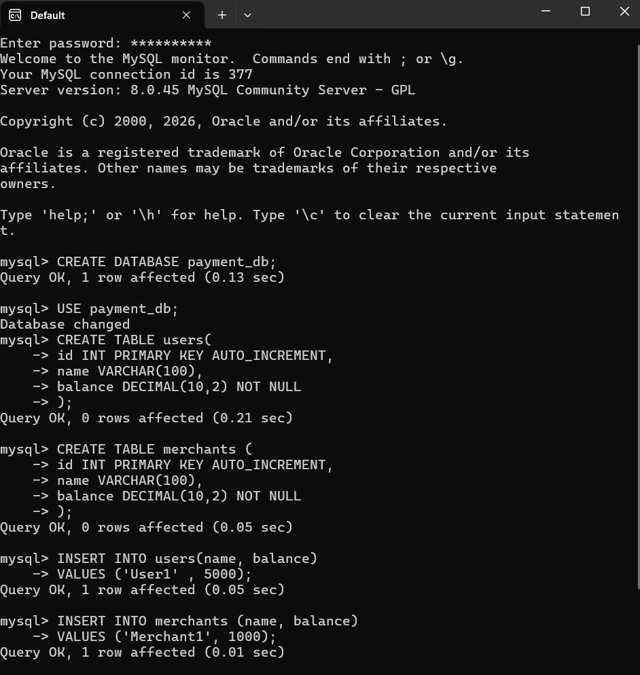
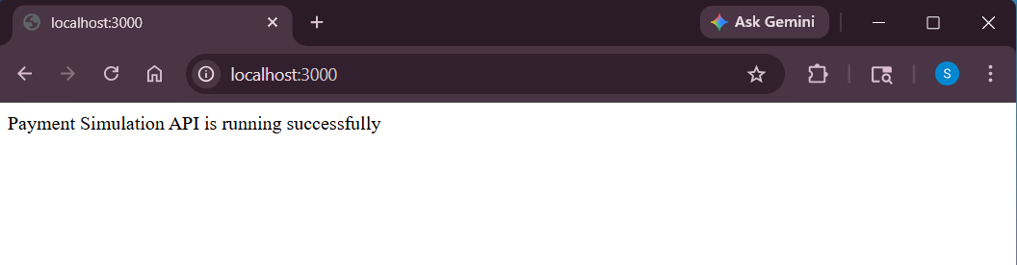

Result:
Payment is processed by deducting money from the user and adding it to the merchant. If all steps succeed, the transaction is committed successfully. If any step fails, the transaction is rolled back to maintain consistency.

